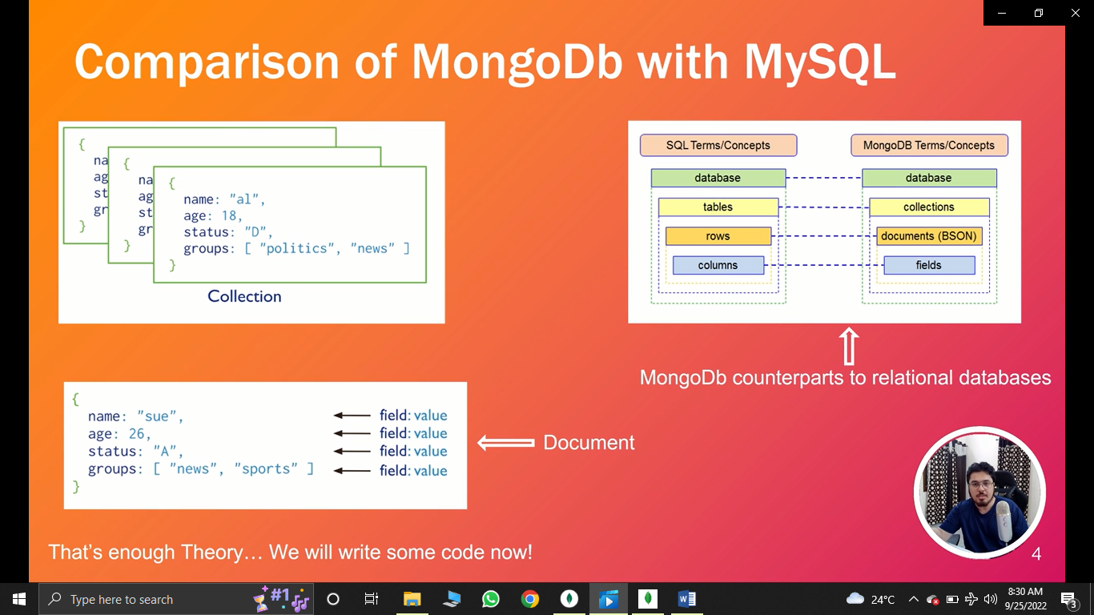

View all data bases

Show dbs

**Create a new DataBases**

Use students //then

db.createCollection(“Courses”)

To switch DataBase

Use students

**View current DataBase**

db

**delete DataBase**

db.dropDatabase()

**Collections related commands**

db.createCollection(‘comments’)

**delete collection**

db.comments.drop()

Command for Rows

**Insert one row**

db.comments.insert({

name:’Zain Ali’,

Language:’JavaScript’,

Member_since:3

})

**Insert multiple rows at a time**

db.comments.insertMany( [

{

name:’Awoni’,

Language:’JavaScript’,

Member_since:3

}, {

Name:’Ahmed’,

Language:’Python’,

Member_since:7

}

] )

**Show all rows in collections (tables)**

db.comments.find()

**find particular row data**

db.comments.find( { name:’Ahmed’, Language:’Python’}

**Limit the number of rows in output**

db.comments.find(2)

**count number of rows in output/collection**

db.comments.find().l